BI1I – PROBLEM SET 04 (90 pts)
Winter Term 2026
Released: Feb 28, 2026
Due: Mar 06, 2026 (midnight)

These questions are meant to sharpen your understanding of the content discussed in class. We hope these questions are engaging enough to encourage collaboration and discussion with your fellow classmates; however, you are each expected to submit individual answer sheets, written in your own words. Please cite any outside sources that you use – at times, these questions walk through specific examples that are outside the scope of the lecture slides, so we expect you to consult textbooks and/or published works/reviews. As described in the course policies, you can NOT use ChatGPT or other AI platforms to write your answers, zero tolerance.

Problem 1: Revisiting TCR signaling with a more nuanced understanding (40 pts)

First, let’s review some of the content discussed in class.

a. In the thymus, T cells go through an extensive selection process that depends on the strength of their TCR binding to MHC-antigen complexes. Describe the fate of the T cell with each of the signaling strengths described below. Why would B cells not benefit from the same selection process that T cells go through (make sure to address differences in BCR vs TCR diversification in your explanation)? 6 pts

No TCR binding to MHC-antigen: This shows that the cell dies since it never receives the survival signal showing that its TCR can recognize self-MHC.

Medium level TCR binding to MHC-antigen: This shows that the TCR can recognize MHC, which is necessary for future antigen recognition in the periphery. These cells mature into T cells and leave. Positively selected.

Extremely strong TCR binding to MHC-antigen: This cell is negatively selected and generally incurs apoptosis because strong binding means there is high self-reactivity and also autoimmune risk.

T cells exit the thymus as “naïve” T cells and enter lymph nodes, where they can meet antigen presenting cells. However, we learned in class that TCR signaling alone is not enough to “activate” naive T cells.
b. Describe all of the signals that are required to activate naive T cells. In your description, make sure to keep track of which receptors/ligands are present on the T cell and what other cell types are involved. Feel free to draw a picture with specific receptors/ligands if this makes more sense to you, but make sure to still clearly state what each signal refers to in general terms. (these activation requirements are commonly referred to as “signal 1”, “signal 2” and “signal 3”) 6 pts
Signal | T cell side | APC/other cell side | What it does
1 | TCR | Peptide MHC on an APC | Signal tells the T cell what the antigen is seeing.
2 | CD28 | B7 molecules on the APC | Confirmaton signal that indicates the antigen is being presented in a dangerous context
3 | Cytokine receptors on the T cell | Inflammatory or polarizing cytokines from APCs and other stuff related to the innate immune functions | Tells the T cell what kind of response is appropriate for the pathogen

c. Conversely, B cells are not activated in the same way T cells are. How are B cells activated? Specifically describe the receptors/ligands and other cell type(s) involved. 4 pts
First the antigen binds to the BCR, then the B cell processes that antigen and presents peptide on MHC II to some helper T cell. The T cell whose TCR recognizes the peptide-MHC II helps by providing CD40L-CD40 costimulation plus cytokines such as IL-4 or IL-21, which subsequently results in things such as B cell proliferation.

Based on your answers above, it should be clear that B cells and T cells rely on other cell types to launch a proper response to an immunological threat. This is a critical concept in immunology, as it speaks to the necessary communication between the adaptive immune system and innate immune system. In fact, the immunologist’s “dirty little secret” is crucial for vaccine development.
Recall: vaccinations often administer little harmless bits of pathogens to preemptively stimulate the adaptive immune system and generate memory T/B cells for future encounter of the pathogen in its full form. The immunologist’s dirty little secret is that the introduction of pathogen-related peptides in their purified form is not enough to stimulate a preemptive immune response; vaccinations require the addition of an adjuvant, or a substance/mixture containing general bacterial extracts or specific molecules (DAMPs/PAMPs = “damage associated” or “pathogen associated molecular patterns”).
d. Using your knowledge of B cell/T cell activation requirements and knowledge of immune cell recognition mechanisms, explain why adjuvant might be necessary for activating the adaptive immune system. 6 pts
Purified antigen can give lymphocytes specificity, but by itself it often does not activate innate sensors strongly enough to mature dendritic cells. Adjuvant is necessary because purified antigen alone should provides signal 1 without enough signal 2 or signal 3. A purified pathogen peptide or protein may be recognized by BCR or TCR but this alone does not tell the immune system that there is a real threat which makes sense given that the adaptive immune system relies on the innate immune system to determine this.

Going back to the T cell’s journey: as discussed in class, after a naïve T cell encounters an antigen presenting cell (APC) where its TCR binds the APC’s MHC-antigen complex, they can either become effector T cells, memory T cells or exhausted T cells.
e. Explain what each of these 3 fates means for the T cell and compare their differing activation requirements. 4 pts
Effector T cells are make cytokines or kill targets immediately after strong antigen exposure with full costimulation and cytokines. Short term.

Memory T cells are produced after successful activation when antigen is eventually cleared and activated cells transition into some memory-like state. They persist after infection or vaccination and respond more rapidly to a second exposure of the same antigen.

Exhausted T cells are made during persistent antigen stimulation, for example cancer or tumors. They progressively lose function and eventually show reduced cytokine production and killing ability.

f. What are the pros and cons of having this higher barrier for T cell activation? (In other words: why would it be bad to have a low threshold for T cell activation? Is having this high threshold a “bad” thing? ) 4 pts
The high threshold is protective because it prevents responses to self or harmless antigens and makes activation more likely to occur only during real danger. The downside is slower or weaker responses to small amounts of antigens (i.e. early infection or tumor), but overall the tradeoff is beneficial because it reduces autoimmunity and self-attack.
In the last problem set, we zoomed in on the TCR-calcium-NFAT pathway. In thinking about T cell exhaustion, you might be wondering how TCR signaling can activate NFAT but not activate the effector functions usually associated with NFAT?
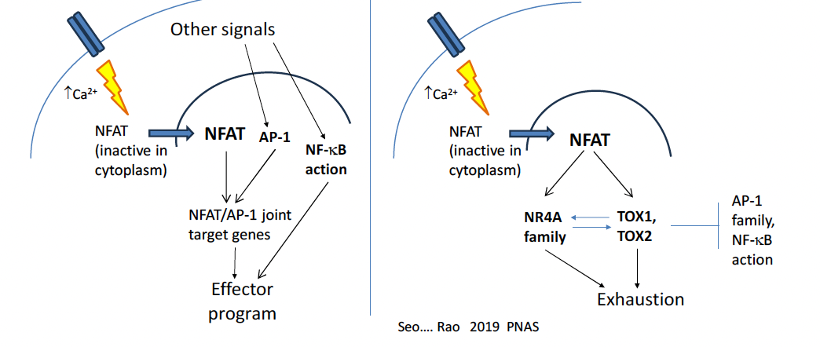
We briefly mentioned this in class, but there is a neat, proposed mechanism to address this question. Being in Bi1i, you know that transcription factors (TFs) like NFAT never really act alone. The presence or absence of other potential binding partners (other TFs) at specific timepoints and at specific concentrations greatly influences TF activity, and NFAT is no exception. Interestingly, NFAT’s activation of effector genes relies on the presence of another transcription factor, AP-1 (diagram above).
This is because many of the genes in the effector program rely on regulatory elements that benefit from the synergistic binding of AP1 and NFAT. These regulatory elements contain binding motifs for both AP-1 and NFAT. As you may recall: although transcription factors prefer ideal binding motifs, the motifs they actually bind in the cell do not always have to be perfect (can be a nucleotide or few off). So, the presence of AP-1, which is downstream other signaling cascades including pathways initiated by costimulatory molecules, pulls NFAT towards their joint motifs, which don’t necessarily contain “perfect” NFAT motifs, to ultimately activate effector genes (left part of diagram).
On the other hand, without AP-1, NFAT does not bind these joint AP-1/NFAT binding sites, and these other binding sites happen to activate the “exhaustion program” and can even repress AP-1 and NF-kB activity (right part of diagram).
Considering the requirements for T cell activation discussed in part b, you become interested in modeling the decision to become an effector vs. exhausted T cell.
g. What would you hope to capture with your model; in other words, what question would you hope to answer with your model? What variables would you want to include? With such a high dimensional space, would you choose to narrow your model to a subset of the system? Or would you attempt to embrace all the complexity? What assumptions might you make and what would you be weary of in making your model? What type of experimental data would you hope to incorporate to verify and test your model? (You don’t need to actually propose a mathematical model, but we hope to encourage creativity with this question now that you have covered a lot of the course content so take it as far as you would like to! There is no “correct” answer, just make sure to explain your thought process and understanding of the biology at play) 10 pts
I would probably want the model to predict when a T cell crosses from an effector state into an exhaustion state. Some variables I’d tarck would include TCR signal strength and duration, antigen abundance, CD28 costimulation, cytokines, Ca2+/NFAT activity, adnAP1/NFkB activity. I would start with a reduced experiment on NFAT, AP1, and costimulation rather than trying to model every direction at once. This would require assumptions about averaging over cell to cell heterogeneity and collapsing many cytokines into a few effective inputs, and I would then need to be cautious because timing, chromatin state, and feedback loops could strongly change the outcome. To test it, I would want time course data such as flow, cytokine production, scRNA-seq, scATAC-seq, and binding or chromatin data for NFAT and AP1.

Problem 2. Cancer Vaccines and T cells. (30 pts)

The expression of cancer/testis (CT) antigens is normally limited to human germ line cells in the testis and to various types of human cancers. A type of a CT antigen is the melanoma-associated antigen gene (MAGE) family. Although MAGE was first discovered in melanoma cells (pigment cells), it is also expressed in testis and in cancer.
MAGE is known to induce spontaneous humoral and cellular immune responses in MAGE-expressing cancer patients, with the result that they are feasible targets for tumor immunotherapy.

MAGE-A4 is also reported to be expressed in a wide variety of tumors, e.g., 60% esophageal cancer, 50% head and neck cancer, 24% non-small-cell lung cancer, 33% gastric tumor, and 21% Hodgkin's disease, but not in normal tissues besides the testis. MAGE-A4 elicits spontaneous humoral or cellular immune responses in patients with MAGE-A4-expressing non-small-cell lung cancer, head and neck cancer, and adult T cell leukemia/lymphoma. Many MAGE-A4 epitope peptides recognized by CD4 and CD8 T cells by MHC class I and class II have been identified.

In this study, the researchers conducted a cancer vaccine clinical trial with a complex of MAGE-A4 protein and cholesteryl pullulan (CHP) nanoparticles in advanced cancer patients. They monitored and analyzed the safety, clinical effect, humoral and cellular immune responses, and expression of antigens in these patients.

The authors “analyzed the ratio of CD4+ Foxp3 high+ cells in CD3+ T cells at baseline from 15 vaccine-completed patients. Patients with a low ratio of CD4+ Foxp3 high+ cells in CD3+ T cells showed longer overall survival than patients with a high ratio after vaccination, although it was not significant.”

a. Based on what you learned in class, what is the general name for CD4+ Foxp3+ T cells? Describe how this specific subset T cells contributes to the immune system. 4 pt
Regulatory T cells. They suppress APCs and lymphocytes, subsequently limiting autoimmunity but also at a cost of sometimes dampening useful anti-tumor responses.

Let’s consider how the transcription factor Foxp3 allows this specific subset of T cells to perform their immunological functions. Foxp3 is known to drive the expression of:
- CTLA-4
- CD25
- IL-10 and TGF-β

b. Explain why Foxp3-driven expression of these targets above allows CD4+Foxp3+ cells to perform their immunological role, as you described in part a. 6 pt
CTLA-4 lets regulatory t cells suppress APC costimulation by competing for/removing, CD80/CD86, so other T cells receive less CD28 signaling. A high amount of CD25/regulator t cells binds IL2 very effectively leaving none for the T cells, which deprives them of a key growth factor while supporting survival of regulator t cells. IL-10 and TGF- β directly suppress inflammatory APC and effector T-cell functions thereby creating an immune-suppresive environment.

c. Now going back to the results of the MAGE-4/CHP treatment –the small sample size prevented the effect seen from being statistically significant, but if the trend were to continue in a larger sample, what would this result say about the impact of CD4+ Foxp3+ T cells on the cancer vaccine treatment? Why might this result make sense from an immunological perspective? 4 pt
If that trend holds in a larger sample size, it would mean higher baseline regulator T cell levels reduce the effectiveness of the MAGE-4 vaccine and are associated with worse survival. That makes immunological sense because regulator T cells suppress costimulation and anti-tumor CD4/CD8 expansion, which are the specific responses the vaccine is trying to induce.

Interestingly, two stable disease patients, P-6 and P-12, belonged in the low ratio group (patients with lower levels of CD4+ Foxp3+ T cells). Looking specifically at P-12 from the study, flow cytometric analyses were performed before and after the vaccination. In this case, flow cytometry was used to measure cytokine production.

A common immunology method (that was not covered in class in extensive detail) is an Intracellular Cytokine Staining (ICS) assay. It is a method used to measure cytokine production in individual cells via flow cytometry. It is primarily used to evaluate T cell function by detecting cytokines like IFN-γ, IL-2, and TNF-α that have accumulated inside the cell.
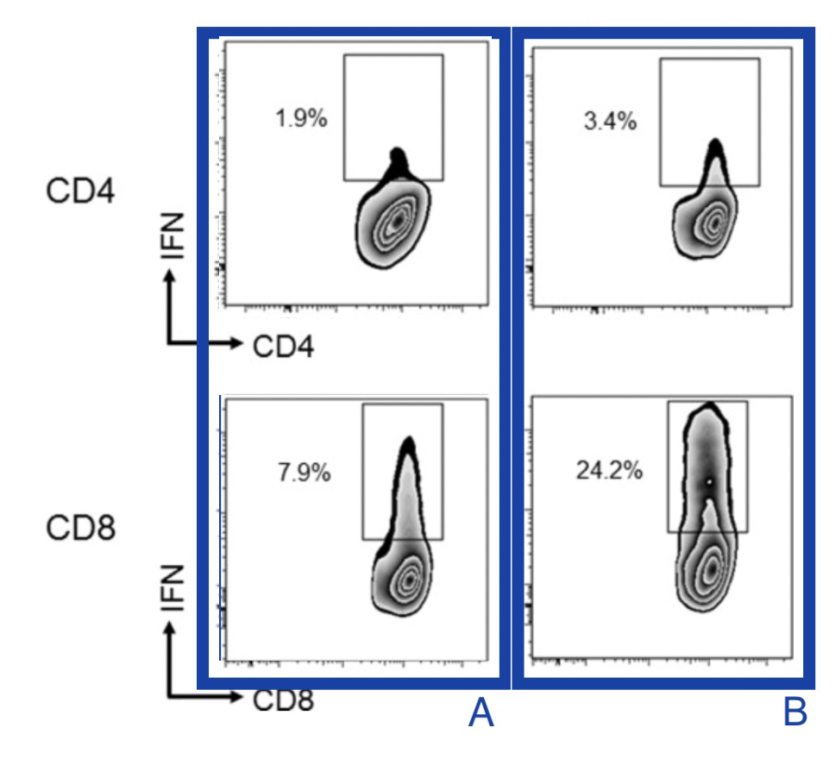
In the following figure, MAGE-A4-specific CD4 and CD8 T cell responses were analyzed by an Intracellular Cytokine Staining (ICS) assay using peripheral blood mononuclear cells (PBMCs) obtained from 15 vaccine-completed patients at baseline and 2 weeks after the 6th immunization. Specifically, CD4 and CD8 T cells were isolated from PBMCs and were then grown together with antigen-presenting cells (APCs) that had been loaded with 31 different overlapping pieces of the MAGE-A4 protein. CD4 T cells were cultured for 21 days, and CD8 T cells were cultured for 8 days. After this growth period, the T cells were collected and stimulated again for 6 hours using APCs loaded with the same MAGE-A4 peptides or with a control (unrelated) peptide. Finally, the researchers measured how many CD4 or CD8 T cells produced interferon-gamma (IFN-γ) using an intracellular cytokine staining (ICS) assay. For their control, CD4 and CD8 T cells were stimulated with APCs loaded with an irrelevant peptide instead of the MAGE-A4 peptide pool (not shown here).

d. The flow cytometry plots to the right show T cell samples that were processed as described above either before the vaccination (A) or after the vaccination (B) where IFN refers to interferon-gamma (IFN-γ). Explain what these results mean, and what they reveal about vaccine impact of CD4/CD8 activity. 2 pt
After vaccination, the fraction of IFN-γ producing MAGE-A4-specific T cells increases in both sides, from 1.9% to 3.4% for CD4 cells and from 7.9% to 24.2% for CD8 cells. This means the vaccine boosted antigen-specific T cell responses, with the strongest effect in CD8 T cells.

The following graphs show MAGE-A4 antibody response analyzed by enzyme-linked immunosorbent assays (ELISAs) using recombinant MAGE-A4 protein with a His-tag, which is used to obtain purified MAGE-A4 protein from a messy sample.

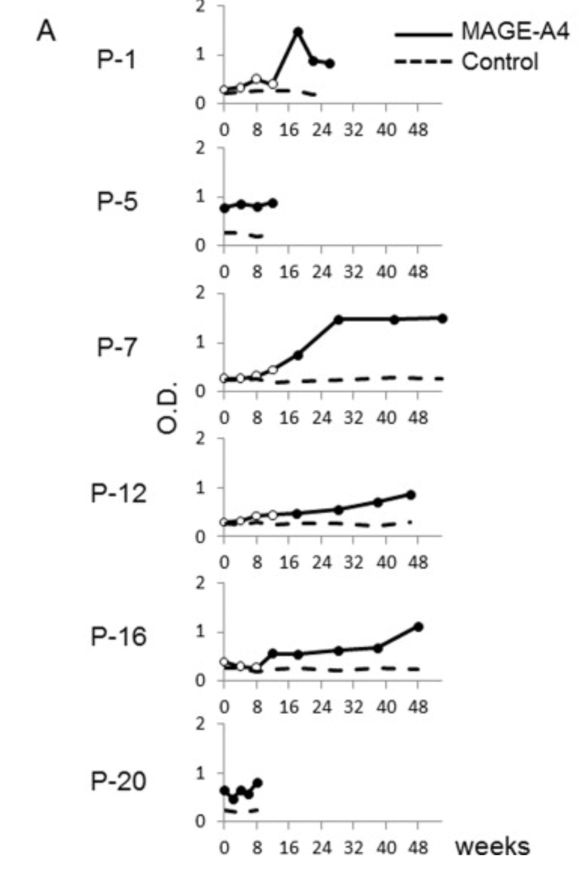
The His-tag technique is a streamlined method for isolating a specific protein by genetically adding a short string of histidine residues (usually 6xHis) to its structure, creating a high-affinity "handle." This tag allows the protein to selectively bind to nickel or cobalt ions immobilized on a resin during Immobilized Metal Affinity Chromatography (IMAC). While the target protein remains stuck to the beads, unwanted cellular debris is washed away; the purified protein is then "freed" or eluted using imidazole, a molecule that mimics the tag and outcompetes it for the metal binding sites. A His-tag was used in the ELISA experiment because for ELISA, large amounts of clean protein are needed so the His-tag makes production and purification practical.The ELISA assay results to the right measure MAGE-A4 antibody levels is blood serum.
In ELISA assays, purified protein (in this case MAGE-A4) are coated on the bottom of a plate that contains multiple wells. Blood serum samples are then added to specific wells (notated as P-1, P-5, etc. to the right). If there are antibodies that bind MAGE-A4 in the patient serum, they bind to the antigen coating the bottom of the wells. The samples are washed so only antigen-bound antibodies remain, and then secondary antibodies are added which are conjugated to enzymes. A substrate is then added, which the enzymes react with to create a colored signal. This colorimetric signal is thus red as an optical density measurement (OD, measured on the y-axis in the plots).

In this case, ovalbumin (OVA) was used as the control protein. OVA is a model antigen that comes from chicken egg whites and is the main allergen that causes egg white allergies. At every time point, patient samples were added to control wells that were coated in purified OVA protein and test wells that were coated in purified MAGE-A4 protein. Vaccine treatment was administered at the 0 timepoint.

e. Based on the description of the experiment above, what does a higher OD value indicate about the patient sample? What OD measurements would you expect for the OVA control wells? 4 pt
A higher OD means more antibodies from the serum sample binded to the coated antigen, so it indicates a stronger anti MAGE-A4 antibody response. The OVA control wells should stay low and relatively flat near background, because the patients were not vaccinated against OVA and any signal there would mainly reflect nonspecific binding.

f. Do you observe patient(s) who already have immunity against MAGE-A4? Which patient(s)? What do the results say about the other patients? Explain how you reached your conclusion. 4 pt
P-5 and P-20 seem to already have immunity to MAGE-A4 because their MAGE-A4 OD is clearly above the OVA control at all timepoints. The other patients start near background or control and then either rise later, which could mean antibody responses induced or created by a vaccine, or remain low if they do not respond strongly.

After this experiment was done, Anti-MAGE-A4, but not anti-His-tag, antibody responses in sera from patients P-1, P-12, and P-16 were analyzed by Western blot analysis using recombinant MAGE-A4 protein without any tags.

f. Why did the researchers specifically focus on Anti-MAGE-A4, but not anti-His-tag antibody responses, for this experiment? Why were anti-MAGE-A4, but not anti-His-tag proteins, used in the previous ELISA experiment? 2 pt
The main question is whether patients made antibodies against the tumor antigen MAGE-A4, not against the artificial purification tag. Using tag free MAGE-A4 in the Western lets the researchers verify that the serum antibodies truly recognize MAGE-A4, while the earlier ELISA used His-tagged MAGE-A4 simply because the tag made protein production/purification practical.
g. Interpret the results from the Western (shown below, where “pre” means before vaccine treatment and the 18w/46w/48w column indicates the weeks after vaccine treatment). Do the results agree with the results from the ELISA? 4 ptow ratio of CD4+ F
The post vaccine lanes for P-1, P-12, and P-16 show stronger bands at the 35 kDa MAGE-A4 size than their corresponding pre vaccine lanes. This means increased anti-MAGE-A4 antibody after vaccination. Yes, this agrees with the ELISA because those same patients showed rising MAGE-A4-specific OD over time.
oxp3 high+ cells in CD3+ Tells 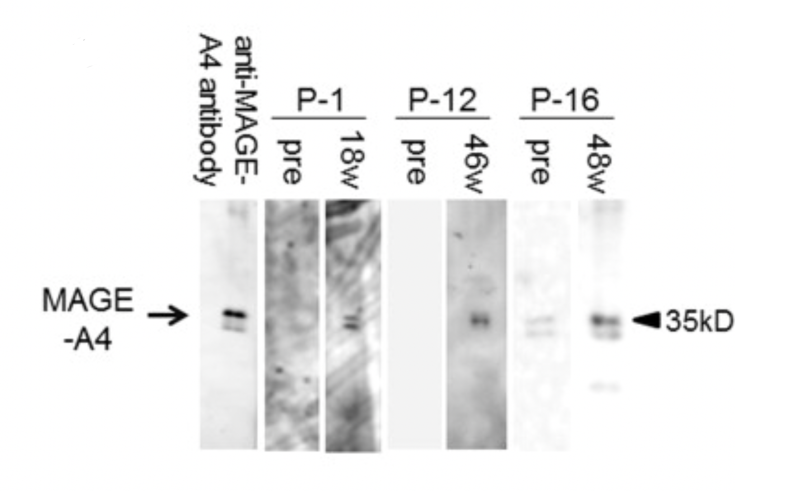

Extra Credit (you are not required to do the following part of Question 2):
Another important use of immunocytes for targeting cancers are Tumor-infiltrating lymphocytes (TILs). TILS are naturally occurring white blood cells (T cells) that have migrated from the bloodstream into a tumor to recognize and attack cancer cells. While they are "battle-hardened" soldiers already trained to identify a patient's specific cancer, they are often too few in number or become "exhausted" by the tumor's defenses to effectively eliminate the disease on their own.

A patient with metastatic (or the cancer had spread to other organs) colorectal cancer was found to harbor a KRAS G12D mutation. The KRAS G12D mutation is a highly prevalent oncogenic driver where the amino acid glycine is replaced by aspartic acid at codon 12 of the KRAS protein. This single-site transition results in a bulky, negatively charged side chain that stabilizes the protein in a constitutively active "ON" state, driving uncontrolled cell proliferation and survival.

Tumor-infiltrating lymphocytes (TILs) isolated from this patient’s lung metastases were shown to recognize a peptide derived from the mutant KRAS protein. T cells enriched for this specificity were expanded ex vivo, and after chemotherapy that depleted lymphocytes (lymphodepleting), the patient was infused with 10¹¹ T cells (75% CD8+ and the remaining were CD4+). High-dose IL-2 was administered after infusion. Most metastatic lesions regressed, although one lesion later progressed. Going back to KRAS, it is a self-protein, but the G12D mutation alters its amino acid sequence. This creates a neoantigen which is a mutant peptide not present during thymic selection, thus allowing T cells specific for the mutated epitope to exist and recognize tumor cells presenting that peptide on MHC class I. The lung metastases were removed to obtain tumor tissue containing tumor-infiltrating lymphocytes. These TILs were screened to identify and expand clones specifically recognizing the KRAS G12D mutant peptide. Lymphodepleting chemotherapy removes regulatory T cells and competing endogenous lymphocytes, increases availability of homeostatic cytokines (IL-7), and improves engraftment and expansion of the infused tumor-specific T cells.

h. Why was IL-2 administered after infusion of the expanded T cells? Extra Credit 1 pt
IL-2 was given to help the infused tumor-specific T cells survive, expand, and maintain their function after the transfer.

i. One lesion later progressed despite initial regression of others. Provide two possible immunological explanations for this escape. Extra Credit 2 pt
One possibility is antigen escape, so lesion may have lost the KRAS G12D antigen, the restricting HLA allele, or antigen processing and MHC I presentation, so the T cells could then no longer see it.
Another possibility is local immune suppressipn, like PD-L1, regulator t cells, or T-cell exhaustion within that lesion’s subenvironment.

Problem 3: Let’s Review! (20 pts)
There is no throughline for this question, we will just touch on various concepts discussed throughout the course to refresh your memory!

a. SNPs, or single nucleotide polymorphisms, are spontaneous genomic sequence variations, some of which can increase the frequencies of certain diseases. As the name suggests, SNPs involve a mutation of a single nucleotide (including a nucleotide insertion, deletion, replication, etc.) PCR can be used to detect the presence of specific SNPs. Describe PCR and why it would be a useful detection tool in the context of SNPs. What design considerations must you take into account (primers)? 5 pts
PCR amplifies specific DNA regions by repeatedly denaturation (separating DNA strands), annealing (primers bind to complementary target sequences), extension (DNA polymerase extends from the primers to copy the region). PCR is useful for SNP detection because it can amplify the DNA region containing the SNP, making it easier to analyze whether that sequence variant is present.

Some things I’d take into account include:
- Primers must bind to the SNP on either side
- They should be specific to the target sequence
- Forward and reverse primers should have similar melting temperatures
- The amplified product should be short enough for efficient amplification

b. When you look at a genome browser software (eg: UCSC genome browser), you might see promoters, enhancers, exons and introns. At which of these 4 regions would you expect to see RNA-sequencing data? At which of these 4 regions would you expect to see ChIP-seq data for a target transcription factor? At which of these 4 regions would you expect to see ATAC-sequencing data, where the presence of peaks indicates “open” chromatin regions? Please explain your reasoning and keep in mind that the answer does not have to be just 1 of the 4 options. 4 pts
I would expect RNA-seq signal over exons since RNA-seq measures RNA molecules transcribed from genes.
I would expect ChIP-seq data at promoters and enhancers because transcription factors bind to DNA elements that control gene expression.
I would expect ATAC-seq peaks at promoters and enhancers as well because these are usually regions of open chromatin that are accessible to transcription factors.

c. The classic symptoms of inflammation involve heat, swelling, redness and pain; on a cellular level, inflammation creates a local microenvironment filled with pro-inflammatory cytokines and chemokines that draw in innate immune cells. Describe at least 3 cell types involved, and how they contribute to this inflammatory response. 5 pts
Macrophages detect pathogens or tissue damage and release cytokines such as TNF, IL-1, and IL-6 that help initiate inflammation, activate nearby cells, and recruit more immune cells.
Mast cells release histamine and other inflammatory mediators. Histamine increases blood vessel permeability, which subsequently contributes to redness, heat, and swelling.
Neutrophils are brought to inflamed tirrue by chemokines and then kill microbes with phagocytosis.

d. B cells have different mechanisms for generating diversity in their BCRs. List all 4 mechanisms and fully describe at least 2 of these 4 mechanisms, making sure to describe what these mechanisms are, why they are important for generating diversity, and at what timepoint these mechanisms occur in a B cell’s lifetime. 4 pts
VDJ recombination, junctional diversity, combinatorial diversity, and somatic hypermutation.

VDJ recombination takes place during B cell development in the bone marrow. The immunoglobulin heavy and light chain genes are assembled by rearranging V/D/J for the heavy chain and V/J for the light chain. This creates many possible gene combinations, allowing different B cells to make different antigen-binding regions.

Junctional diversity also occurs during early B cell development in the bone marrow during VDJ recombination. When gene segments are joined, nucleotides may be randomly added or removed at the junctions. This creates extra sequence variation at the exact joining sites, which subsequently increases diversity in the antigen-binding region.

e. Most “mature” or “terminally differentiated” cells in your body are not able to proliferate. Why is it important that T cells and B cells still maintain proliferative ability? 4 pts
T and B cells must proliferate because antigen-specific lymphocytes are initially very rare. When the body encounters a pathogen, the few B or T cells that recognize that antigen must do clonal expansion to generate enough effector cells to fight the infection.
Proliferation is also needed to generate memory cells, to respond better to second time infections, enforcing the important adaptive immunity.

